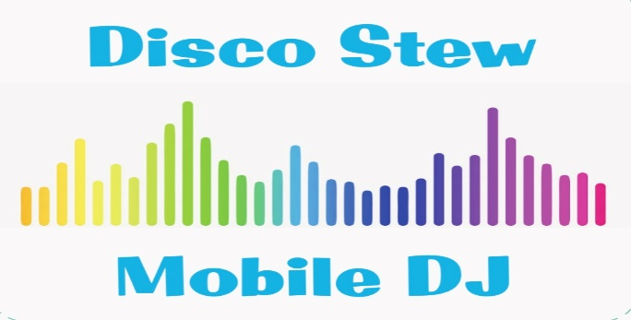

WEDDING DJ QUESTIONNAIRE:

Wedding Date: ____________ Day: ____________ Time: ____________

Brides Name: ________________________________________________________

Grooms Name: _______________________________________________________

Wedding Ceremony Venue: ____________________________________________

Wedding Reception Venue: ____________________________________________

Bride Contact Number: ________________________________________________

Groom Contact Number: _______________________________________________

Ceremony Start Time: ____________
Reception Start Time: ____________ Number of Guests: ____________

(Note: Disco Stew Mobile DJ typically arrives an hour and a half beforehand to set-up)

Wedding DJ Questionnaire Page 2

Bridal Party Arrival to Reception Time: ____________

Introductions:
Announce that guests can request songs? Yes or No
Announce for guests to sign the guest book or picture frame? Yes or No

Bridal Party Introduction:
Bridal Party Introduction / Entrance Song: _____________________________
(I recommend only first names for the bridal party to make it more intimate)

Bridesmaids: Groomsmen:

- (Flower Girl) ______________________________ 1. (Ring Bearer) ______________________________

- (Jr. Bridesmaid) ___________________________ 2. (Jr. Groomsmen) ____________________________

- _________________________________________ 3. ___________________________________________

- _________________________________________ 4. ___________________________________________

- _________________________________________ 5. ___________________________________________

- (Maid of Honor) ___________________________ 6. (Best Man) _________________________________

Wedding DJ Questionnaire Page 3

Bride and Groom Introduction:

Introduction Song: _________________________________________________________
“Ladies and Gentlemen, it is my honour to introduce to you:

Mr. & Mrs. ________________________________________________________________

Cake Cutting:
Cake Cutting Songs: 1. _____________________________________________________________

2. _____________________________________________________________

**Note: (Cake cutting can be done straight after introductions or after dinner service as a guide)

Toasts / Speeches:

- Best Man: ______________________________

- Maid of Honour: _________________________

- ________________________________________

- ________________________________________

- ________________________________________

Wedding DJ Questionnaire Page 4

Special Dances:

Bride and Groom First Dance Song: ______________________________________

Bridal Party Dance Song: ______________________________________________

Bride and Father Dance Song: __________________________________________

Groom and Mother Dance Song: ________________________________________

Additional Dances: Yes or No

Special Ceremonies (Optional):

Garter Removal Song: ________________________________________________

Garter Toss Song: ____________________________________________________

Bouquet Toss Song: _________________________________________________

Announce Last Drinks: Yes or No

Last Song of the Night: _________________________

Wedding Reception Ending Time: _________________

Function Managers Name:

Photographers Name:

Videographers Name:

Celebrants Name:

Wedding DJ Questionnaire Page 5

Notes for the Wedding DJ:

- Is it ok to take song requests from the guests? Yes or No
- If a song is killing the dance floor, can the DJ fade out the song even if it is a request from a guest? Yes or No
- From your playlist as well? Yes or No

Any additional information? ____________________________________________

__________________________________________________________________________

__________________________________________________________________________

Types of Music you Would like Played:
Please circle the genres of Music that you would like played.
And also the Music you think your guests will like:

OLDIES (50’s & 60’s) MOTOWN ROCK COUNTRY

70’s 80’s 90’s 2000’s R&B

HIP HOP TECHNO TOP 40 (POP) ALTERNATIVE

HOUSE PUNK 70’s DISCO 2010’s HEAVY METAL

Wedding DJ Questionnaire Page 6

Line Dances: (Select the ones you would like played.)

Cha Cha Slide: Yes or No Hokey Pokey: Yes or No
Macarena: Yes or No Gangnam Style: Yes or No
Y.M.C.A. : Yes or No The Twist: Yes or No
The Train: Yes or No Chicken Dance: Yes or No
Bus Stop: Yes or No Nutbush: Yes or No
Time Warp: Yes or No Zorba’s Dance: Yes or No

Dancing Song Requests:

Must Have’s Song Requests: Do NOT Play Songs:

- _____________________________ 1. ___________________________

- _____________________________ 2. ___________________________

- _____________________________ 3. ___________________________

- _____________________________ 4. ___________________________

- _____________________________ 5. ___________________________

- _____________________________ 6. ___________________________

- _____________________________ 7. ___________________________

- _____________________________ 8. ___________________________

- _____________________________ 9. ___________________________

- _____________________________ 10. ___________________________

Wedding DJ Questionnaire Page 5

Ceremony Music (Optional):

- Seating Music for Guests Arriving:
(**Note: Disco Stew Mobile DJ typically plays a half hour of Gentle seating music before the ceremony starts while guests are arriving.)

- Bridal Party and Family Ceremony Entrance Song (Processional):

________________________________________________________

- Bride Ceremony Entrance Song:
_________________________________________________

- Bride & Groom Ceremony Leaving Song:
_________________________________________________

**Note: Please come with an idea of the order in which Family and the Bridal Party will be entering in for the Ceremony. This will help with cueing up the music during the Ceremony.

Please Bring this questionnaire (and any other relevant information) to your
DJ Meet & Greet in the lead up to your Special Day.

Alternatively you can email it to: info@discostewmobiledj.com

Many Thanks & I really look forward to your upcoming Wedding!!

